PortaWell Newsletter
Volume 1 August 2021

Tips and Tricks for Emergency Water Filtration
In this issue:
Water filters
Selection
Placement
One PortaWell Customer asked the question:
Does it matter which filter I use and which one I place in the first stage or the second stage when I filter surface water to be used for drinking, food preparation, etc.?

PortaWell is shipped with three different filters, each with a unique purpose. The filters are a 5-micron sediment filter, a .5-micron ceramic filter and a 5-micron Carbon Block filter. The sediment filter is usually placed in the first stage and acts as a prefilter to remove the larger particles before passing through the ceramic filter placed in the 2nd stage. Some points to consider based on my experience using PortaWell:
- Always choose the best water quality as your source water. Water that is heavily silted or loaded with algae will foul any filter quickly.
- There may be times it is best to filter the water twice. If the water source is suspected of having both biologic (bacteria or cysts) and chemical contamination (organics such a pesticides or herbicides) like from a neighborhood rainwater retention pond, it might be best to run the water through the PortaWell two separate times: First with prefilter (sediment) in the first housing and with the ceramic filter in the second housing to remove all bacteria, cysts and particulate followed by a second filtration with the ceramic filter in the first housing and the carbon block (ABS filter) in the 2nd housing.
- There are commercially available combo filters that have a ceramic shell outside and an inner carbon core to remove both biologic and chemical contamination. Aqua Cera sells one called Cera Metrix that fits the PortaWell.

Here are some general guidelines I have come up with:
Selection of Filter and Filter sequence

Treatment/Filter Purpose
1. Sediment (Used to remove particulate >5 microns)
2. Ceramic (Used to remove submicron contaminants including giardia, crypto and bacteria)
3. Carbon Block (Used to remove Volatile organic chemicals, toxins, and chlorine)

Note: The filters listed/ supplied do not remove inorganic dissolved solids such as magnesium and calcium (hard water). They also do not remove salt from seawater.

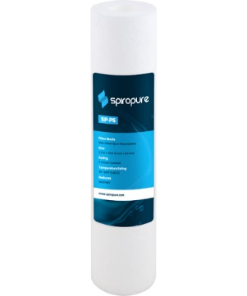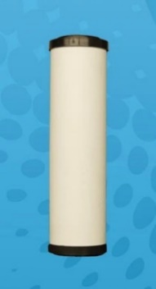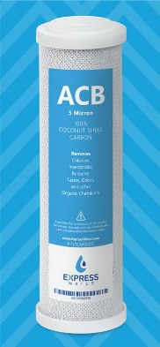

Sediment Ceramic Carbon Block

Contaminant Categories
1. Biologic
- Bacteria, Cysts (>.5 to 1-micron diameter)
- Virus (< .5-micron diameter)
2. Organic Chemical
- Pesticides
- Total Organic Carbon, Industrial Solvents,
- Aromatic compounds
- Algae color and cyanobacteria toxins
3. Organic plant
- Algae, Moss, plant/animal decay
4. Inorganic Chemicals
- Chlorine
5. Sediment
- Dirt, silt, sand

Water contamination filter selection guide
Note: This table is for information only and it is the responsibility of the user to select the appropriate water source and filter setup as some water sources may have additional contaminants than shown below.

Water Source | Water Quality | Likely Water Contaminant | Treatment/Filter Sequence (stage)
¹Pond | Turbid | 1,2,3 4, 5 | 1,2, and 2,3
Mountain Stream | Clear | 1 | 1,2
¹River, Canal | Turbid | 1,2,5 | 1,2 and 2,3
Lake | Clear | 1, 5 | 1,2
Runoff Retention Pond | Clear | 1,2 | 1,2 and 2,3
Spring | Clear | 1? | 1,2
Swimming Pool | Clear | 1,2,5 | 2,3

¹Clorination of the water may be considered after the first filtration removes the particulate if the water is suspected of being contaminated with organic waste (sewage or livestock runoff). EPA guidelines are up to 3ppm of chlorine treatment. The carbon filter will remove up to 90% of the chlorine.
Note: Best practice is to always place the carbon block filter after the ceramic filter.
This prevents the carbon filter from becoming potentially contaminated and prevents
premature fouling of the ceramic filter due to shedding of small carbon particles
during the initial phase of filtration.

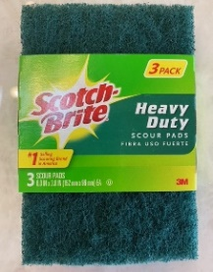
The sediment filter is used to protect the fine pored ceramic from early fouling and should be replaced after heavy use (badly discolored). The ceramic filter is cleanable. There are videos posted on you tube (search “cleaning ceramic water filters” that explain the process to clean the filter. I use a “clean” Scotch Pad (clean means no soap and has not been previously used to scour a greasy pan) and lightly scrub to remove the top layer of discoloration. Rinse the filter with clean water taking care not to allow rinse water on the inside of the filter. The ceramic filter is brittle and easily cracked, so handle with care. If it is cracked, it must be replaced.
The carbon filter manufacturer recommends replacement every 6 months for average water quality and usage. I have found when using the charcoal filter, it is best to pump the canister full of water and let it sit for 15 minutes or so to increase its absorption capacity before pumping water through it.
The following provides specifications for the Ceramic and Carbon Block filters provided with PortaWell.
CeraSyl™ silver-impregnated ceramic DE (diatomaceous earth) shell only.
Excellent as a standalone filter for removing unwanted sediment and bacteriologic contaminants.
- Made in USA
- Cleanable for prolonged life
- Silver impregnated to prevent bacteria grow through
- 0.5 Micron absolute
- 100% Removal of cysts
- 99.9999% Pathogenic bacteria
- >99.9% Efficiency at 0.2 micron
- Capacity - Up to 15,000 gallons/57,000 liters
ACB Charcoal Filter
- Filtration size: 5 microns
- Material: Polypropylene shell, Silicon Ring, Coconut Husk Carbon
- Life Cycle: 6 Months
Impurities Reduced: Chlorine, Total Organic Carbon (TOC), Pharmaceuticals, Turbidity, Volatile Organic Chemicals (VOC), Industrial Solvents, and Chemicals causing bad tastes, odors, and Chlorine
Sediment Filter
The SpiroPure SP-P5 spun polypropylene water filter cartridge reduces sediment for a variety of water filtration needs, including residential, commercial, and municipal drinking water, and fits any standard filter housings that use 10" x 2.5" filter cartridges.
- Reduces fine sediment particles from residential, commercial, and municipal drinking water
- Nominal filtration rating of 5 micron
- Initial pressure drop of <1 psi at a flow rate of 10 gpm
- Temperature rating of 40°F to 180°
- Made with melt-blown spun polypropylene filter media

